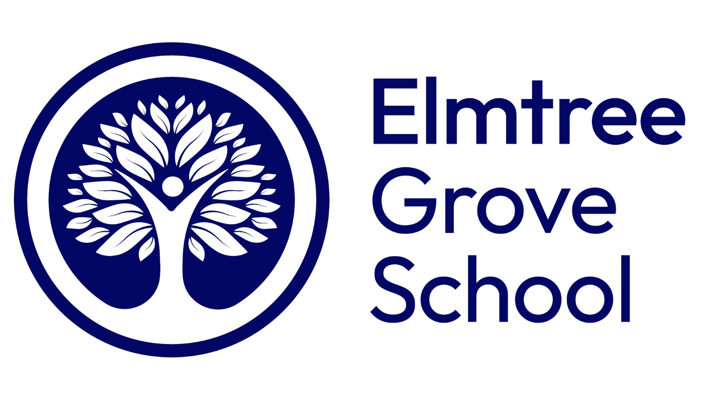

Monitoring and Assessment Policy

- Impact
- Effective Monitoring
- Assessment
- Learner Voice

Effective from: 1st Dec 2025
Review date: 1st Sept 2026
- Impact

At Elmtree Grove School the impact of our curriculum is evidenced by the work our learners produce, their progression over time and how well they are prepared for future learning, work and life.

The wider impact of our curriculum is strongly linked to our curriculum intent.
- Learners are enthused by learning and achieve positive outcomes.
- Learners will remember what they have learnt and make progress in all areas.
- Learner will leave us with reading age beyond a functional level, and they are well-prepared for their next stage in their education.
- Learners will achieve the outcomes and targets set and outlined in their EHCP and PEPs.
- Pupils will become more independent in their learning.
- Learners will be socially and emotionally prepared for the transition to their next stage in education.
- Learners will feel accepted and valued. They will demonstrate improved self-esteem and confidence.
- Learners will know how to keep themselves safe and healthy and they will have developed a range of positive coping strategies.
- Learners will have an awareness of their rights and responsibilities, understand British Values and their valuable position in society.
- Learners will be able to demonstrate respect, kindness and pride. They will be able to form positive relationships with their peers.

- Effective Monitoring

At Elmtree Grove school we are committed to effective monitoring to bring about positive outcomes for all learners.

Effective monitoring at Elmtree Grove School:
- Promotes high quality learning and teaching throughout our school.
- Supports effective planning and resourcing.
- Identifies strengths and weakness in our curriculum offer.
- Identifies requirements for staff CPD and sharing of good practice.
- Provides information to support self-evaluation and school improvement.
- Ensures consistency throughout the school.
- Ensures every learner is making good progress academically and is appropriately being challenged.

Our primary tool for school Monitoring and Assessment follows the standards for independent schools and ensures that all aspects of the school’s performance are systematically and regularly reviewed as part of an annual cycle. Monitoring and Assessment in our school are part of a planned process and involve all staff in the school. There are five components to our monitoring:
  - At least two whole school learning walks each week completed by a member of the leadership team. In addition to these, we complete more specific learning walks focusing on a particular area (e.g. use of visuals in the classroom, colourful semantics, cognitive modelling etc).
  - Termly books looks and scrutinies.
  - Attainment data to be reviewed at the end of each term, based on ongoing assessment and teacher judgements.
  - Three moderation meetings (Terms 2, 4 and 6) to ensure consistency and share best pratice.
  - Three teacher observations per year and feedback given using instructional coaching to help teachers take small, personalised steps to improve their practice.

- Assessment

At Elmtree Grove school we use Assessment and Monitoring as a key part of our approach to inform the next steps for pupils and to monitor the wider impact of our curriculum. This takes place termly with being recorded on our central assessment system along with pupil progress meetings to discuss potential barrier’s and next steps for individual learners.

Due to the gaps in learning that some of our pupils have previously experienced, some learners may not be yet able to achieve the national expected standard in their tests KS2 SATs. If is believe a learner can achieve their KS2 SATs, parents will be notified in writing of our intent for them to sit these external tests.

All learners participate in Thrive (a program that supports children's emotional and social development to improve their mental health and ability to learn), with every learner having a termly reviewed action plan which then becomes part of their educational offer.

4: Pupil Voice

At Elmtree Grove school, pupil voice makes a significant contribution to the school’s Monitoring and Assessment cycle. We value everyone’s thoughts, and each term pupils get an opportunity to feedback on their experiences of school, teaching and learning in the following ways:

- Class discussion about a range of issues related to their experiences of school.
- School Improvement Box where pupils can share their ideas of how the school could be improved for improvement.
- Activities in tutor time to plan a range of school-based activities to improve their experience.
- Student council to feedback and ideas from each class.

